SAN JOSE MUSEUM OF ART AND
INSTITUTE OF THE ARTS AND SCIENCES AT UCSC TO PRESENT
SADIE BARNETTE: FAMILY BUSINESS OPENING MARCH 10, 2023

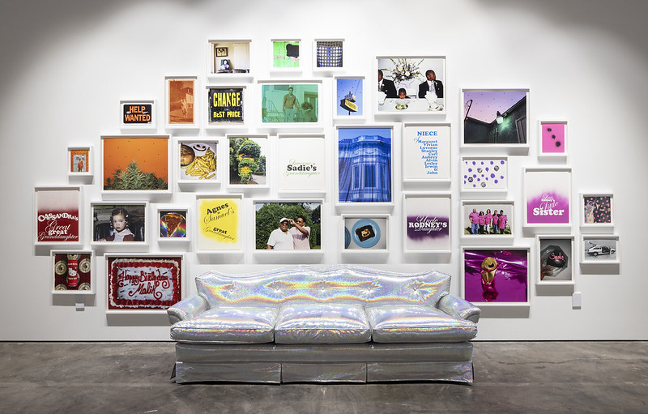
For Immediate Release
San José, California (January 11, 2023; updated February 21, 2023) — The San José Museum of Art (SJMA) and Institute of the Arts and Sciences at UC Santa Cruz (IAS) present Sadie Barnette as the next artist in their ongoing series of new commissions, Visualizing Abolition. On view from March 10 through October 15, 2023, Sadie Barnette: Family Business explores the artist’s family history as it mirrors a collective history of Black repression and resistance in the United States.

At SJMA, Barnette will debut her first video, extending her work with family and historical documentation and reclaiming histories of violence by foregrounding love and humanity. This newly commissioned video will be displayed in SJMA’s galleries in a domestic installation, comprised of drawings, photographs, sculptures, and furniture. The presentation at IAS in Santa Cruz will feature a selection of Barnette’s FBI Drawings in a new wallpaper installation and opens April 28 and is on view through September 3, 2023.

“In her work, Sadie Barnette draws from her own family history, knowing that their experiences under state surveillance and violence echo across Black America. With glitter, holographic materials and hot pink, she reclaims that oppression with love, beauty, and possibility,” said Lauren Schell Dickens, chief curator, SJMA.

In her ongoing series FBI Drawings, Barnette works from the 500-page surveillance file amassed on her father, Rodney Barnette, by the FBI. As founder of the Compton, California chapter of the Black Panther Party in 1968 and bodyguard to abolitionist and icon Angela Davis during her infamous San Jose trial in 1972, Rodney Barnette’s everyday movements and activities were under constant surveillance. Barnette creates monumental and painstaking graphite drawings of these clinical documents, covering them with roses and Hello Kitty profiles, effectively smothering records of state-sanctioned terror with Black joy and power.

The domestic spaces of living rooms and kitchens play a key role in this history, as the settings where protests are planned, relationships nurtured, where Black love and family thrive on a daily basis. The space of the domestic—which appears in Barnette’s work as wallpaper, glitter-covered couches and living room furniture, stereo systems, and family photographs—contradicts official state narratives. The domestic space of familial love and support, proposes an alternate history of Black America, outside of state control, giving space for relationships, love, family, celebration, hope; all of the things that make up the fullness of human experience which are omitted from official state documents and histories.

Sadie Barnette: Family Business is commissioned as part of Visualizing Abolition, an ongoing initiative exploring art, prisons, and justice. With exhibitions collaboratively organized by the Institute of the Arts and Sciences at University of California, Santa Cruz and San José Museum of Art, Visualizing Abolition highlights the creative work underway by artists, activists, and scholars to imagine alternatives to current injustices. Visualizing Abolition is organized by UCSC Professor Gina Dent and Dr. Rachel Nelson, director of IAS, in partnership with Lauren Schell Dickens, SJMA chief curator.

SADIE BARNETTE
Sadie Barnette is from Oakland, CA, where she currently lives and works. Barnette has a BFA from CalArts and an MFA from University of California, San Diego. She has been awarded grants and residencies by The Studio Museum in Harlem, Art Matters, Skowhegan School of Painting and Sculpture, the Headlands Center for the Arts, and the Carmago Foundation in France. She has enjoyed solo shows in the following public institutions: ICA Los Angeles, The Lab and the Museum of the African Diaspora, San Francisco; MCA San Diego; the Manetti Shrem Museum, UC Davis; the Benton Museum of Art at Pomona College; and The Kitchen in New York. Her work is in many permanent collections, including the San José Museum of Art, Los Angeles County Museum of Art, Brooklyn Museum, Pérez Art Museum, Guggenheim Museum, Oakland Museum of California, Studio Museum in Harlem, and the Walker Art Center, as well as a permanent, site-specific commission at the Los Angeles International Airport forthcoming in 2024.

PROGRAMMING
Members Preview
Thursday, March 9, 2023 | 4–9pm
SJMA members exclusive.
Opening Celebration
Friday, March 10, 2023 | 6–9pm
Free admission for everyone.
Creative Minds: Sadie Barnette
Friday, June 9, 2023 | 7pm
Free with Museum admission.
For up-to-date information on programs and events, go to sjmusart.org/calendar.

SUPPORT
Sadie Barnette: Family Business is supported by the SJMA Exhibitions Fund, with generous contributions from the Myra Reinhard Family Foundation, the Richard A. Karp Charitable Foundation, the Mellon Foundation, and support from Jessica Silverman Gallery.
Operations and programs at the San José Museum of Art are made possible by generous support from SJMA’s Board of Trustees, a Cultural Affairs Grant from the City of San José, the Lipman Family Foundation, the Richard A. Karp Charitable Foundation, Sally Lucas, Yvonne and Mike Nevens, the David and Lucile Packard Foundation, the Yellow Chair Foundation, the John S. and James L. Knight Foundation, Brook Hartzell and Tad Freese, the SJMA Director's Council and Council of 100, the San José Museum of Art Endowment Fund established by the John S. and James L. Knight Foundation at the Silicon Valley Community Foundation, and the William Randolph Hearst Foundation.
UNIVERSITY OF CALIFORNIA, SANTA CRUZ INSTITUTE OF THE ARTS AND SCIENCES
Located in the city of Santa Cruz, the Institute of the Arts and Sciences Galleries are a vital new arts hub for the region. As the keystone public galleries at UC Santa Cruz, the Institute of the Arts and Sciences presents a unique vision for the arts at the forefront of social transformation. Drawing on the resources of a leading research university, the world-class exhibitions at the IAS engage the most critical issues of our time, catalyzing meaningful encounters with the arts and ideas.
The Institute of the Arts and Sciences Galleries are located at 100 Panetta Avenue, in the westside of Santa Cruz. Opening February 5, 2023, the galleries will be free to the public and open Tuesday–Sunday 12pm–5pm.

SAN JOSE MUSEUM OF ART
The San José Museum of Art (SJMA) is a modern and contemporary art museum dedicated to inclusivity, new thinking, and visionary ideas. Founded in 1969 by artists and community leaders, its dynamic exhibitions, collection, and programs resonate with defining characteristics of San José and the Silicon Valley—from its rich diversity to its hallmark innovative ethos. The Museum offers lifelong learning for school children and their educators, multigenerational families, creative adults, university students and faculty, and community groups. SJMA is committed to being a borderless museum, essential to creative life throughout the diverse communities of San José and beyond.
SJMA is located at 110 South Market Street in downtown San José, California. The Museum is open Thursday 4–9pm; Friday 11am–9pm; and Saturday–Sunday 11am–6pm. Admission is $10 for adults, $8 for seniors, and free to members, college students, youth and children ages 17 and under, and school teachers (with valid ID). Admission is free from 6–9pm on the first Friday of every month. For up-to-date information, call 408.271.6840 or visit SanJoseMuseumofArt.org.
Press Contacts:
Melanie Samay, director of marketing and communications, San José Museum of Art
msamay@sjmusart.org, 415.722.0555

Frederick Liang, marketing and communications coordinator, San José Museum of Art
fliang@sjmusart.org, 408.291.5374

Maureen Dixon Harrison, associate director, communications and marketing for the Arts Division, University of California, Santa Cruz
maureen@ucsc.edu, 831.459.3277

Press Images:
flickr.com/gp/sjma/2JncQ5Sc99

Image Credit:
Sadie Barnette, Family Tree II, 2022. Photo by Henrik Kam. Courtesy of the artist, Jessica Silverman, San Francisco, and McEvoy Foundation for the Arts, San Francisco.

